

COMPUTING APTITUDE MINI PROJECT
ON
LIBRARY MANAGEMENT SYSTEM

SUBMITTED BY: SUBMITTED TO:
ROHAN & NARESHDEEP MR. SANDEEP KUMAR
UID – 23BCA10072 & 23BCA10134 SIGNATURE:
SECTION - 9A

Abstract
- A C++ console-based Library Management System.
- Automates library tasks: add, search, issue, and return books.
- Maintains records using file I/O for persistence.
- Demonstrates OOP, file handling, and modular design.
Introduction
- Manual record-keeping in libraries is slow and error-prone.
- The system simplifies and automates core operations.
- Practical mini project demonstrating C++ programming skills.
- Includes classes, file handling, and structured logic.

Problem statement & Objectives
Problem: Managing library books and members manually is inefficient.

Objectives:
- Manage books and members efficiently.
- Automate issuing and returning of books.
- Store and retrieve data from text files.
- Demonstrate object-oriented and modular design.

System Design / Approach
Architecture Overview:
- Data Layer: File-based storage (books.txt, members.txt).
- Domain Layer: Classes – Book, Member, Library.
- Presentation Layer: Menu-driven console UI.

Flow:
Start → Load Data → Menu → Action → Update Data → Save → Exit Class Diagram (Simplified)
Library 1 --- * Book
Library 1 --- * Member

Book: id, title, author, total, available
Member: id, name, issued_books

Key Classes: Book, Member, Library

Flowchart
Start
↓
Load data from files
↓
Display Menu
↓
Perform selected operation
↓
Update records
↓
Save changes
↓
Exit

Implementation
Modules:
- book.h / book.cpp — Book class and methods.
- member.h / member.cpp — Member data and operations.
- library.h / library.cpp — Manages operations, handles file I/O.
- main.cpp — Menu-driven interface.

Concepts Used:
- Classes and Objects
- File Handling
- Vectors and Maps (STL)

Key Code Snippet
bool issueBook(int bookId, int memberId) {
if (!books.count(bookId) || !members.count(memberId)) return false;
Book &b = books[bookId]; Member &m = members[memberId];
if (b.available <= 0) return false;
b.available--; m.issued.push_back(bookId); cout << "Book issued"; return true;
}

Highlights:
- Ensures availability before issuing.
- Updates both book and member data.

Results
C++ code of library management system:
#include <iostream> #include <string> using namespace std;

struct Book {
int id; string title; string author; bool isIssued;
};

class Library {
Book books[100];
int count;

public: Library() { count = 0;
}

void addBook() { cout << "\nEnter Book ID: "; cin >> books[count].id; cin.ignore(); cout << "Enter Book Title: "; getline(cin, books[count].title); cout << "Enter Author Name: "; getline(cin, books[count].author); books[count].isIssued = false; count++; cout << "Book added successfully!\n";
}

void showAllBooks() {
if (count == 0) { cout << "\nNo books in library!\n";
return;
}
cout << "\n--- Library Books ---\n"; for (int i = 0; i < count; i++) { cout << "ID: " << books[i].id
<< " | Title: " << books[i].title
<< " | Author: " << books[i].author
<< " | Status: " << (books[i].isIssued ? "Issued" : "Available") << endl;
}
}

void issueBook() {
int id;
cout << "\nEnter Book ID to issue: ";
cin >> id; for (int i = 0; i < count; i++) { if (books[i].id == id) { if (!books[i].isIssued) { books[i].isIssued = true; cout << "Book issued successfully!\n";
} else {
cout << "Book already issued!\n";
} return;
}
}
cout << "Book not found!\n";
}

void returnBook() {
int id;
cout << "\nEnter Book ID to return: ";
cin >> id; for (int i = 0; i < count; i++) { if (books[i].id == id) { if (books[i].isIssued) { books[i].isIssued = false; cout << "Book returned successfully!\n";
} else {
cout << "Book was not issued!\n";
} return;
}
}
cout << "Book not found!\n";
}
};

int main() { Library lib; int choice;

while (true) { cout << "\n--- LIBRARY MANAGEMENT SYSTEM ---\n"; cout << "1. Add Book\n";
cout << "2. Show All Books\n"; cout << "3. Issue Book\n"; cout << "4. Return Book\n"; cout << "5. Exit\n"; cout << "Enter your choice: "; cin >> choice;

switch (choice) { case 1: lib.addBook(); break; case 2: lib.showAllBooks(); break; case 3: lib.issueBook(); break; case 4: lib.returnBook(); break; case 5: cout << "Exiting..."; return 0; default: cout << "Invalid choice!\n";
}
}
}
Output:
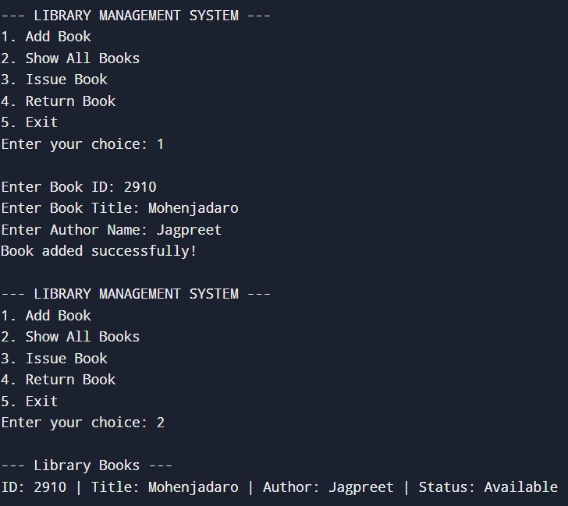
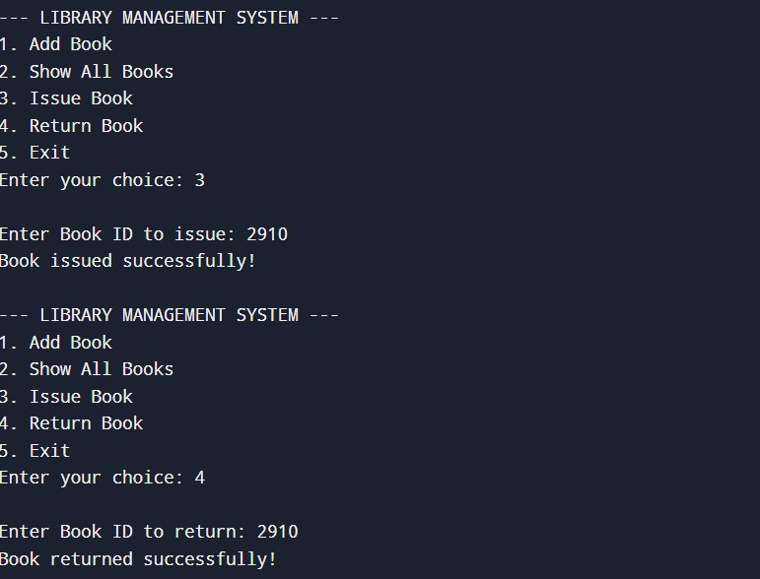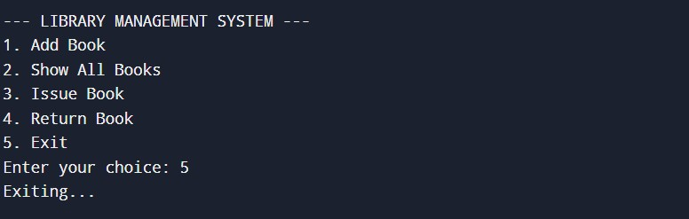

Conclusion
- Functional Library Management System implemented in C++.
- Demonstrated OOP, file handling, and persistence.
- Enhances programming and logical design skills.

Future Enhancements:
- GUI interface
- Database integration (MySQL/SQLite)
- Add fine management and due dates

References
- Bjarne Stroustrup, The C++ Programming Language
- https://en.cppreference.com/
- Online tutorials and documentation

